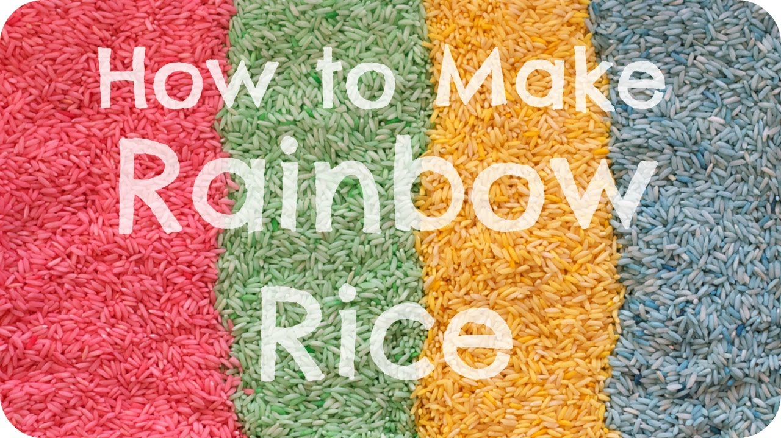

You will need-

- long grain white rice
- vinegar
- food colouring
- food storage container with lid

INGREDIENTS FOR EACH COLOUR OF RICE:
- 1 cup of rice
- 1/2 tsp vinegar
- several drops of liquid food colouring

How to Dye Rice
- Add Food Colouring
Pour a cup of rice into a plastic container. Then add several drops of food colouring and mix through the rice with a spoon. 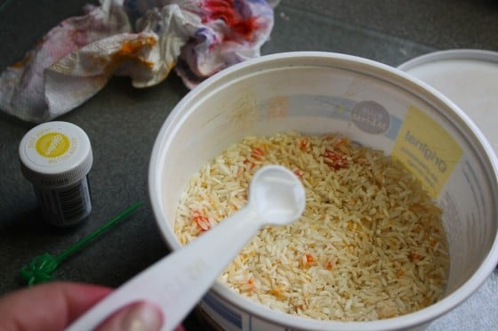
- Add Vinegar
Drizzle 1/2 tsp of vinegar over the rice.
- Shake
Pop the lid on your container, and shake the heck out of it. Remove lid, and be amazed!

DRYING YOUR COLOURED RICE
Spread each batch of coloured rice out on a plate or a baking sheet.
Place your rice in the sun or by the fire to dry quickly, or leave in a safe spot for a few days to dry out.
